JSP Tutorial
Enterprise Architecture
HNDIT 2 Year
Task 01:
- Create a new java web project using NetBean IDE
- Edit index.html file as follow: parameter of this page passes to disfn.jsp.
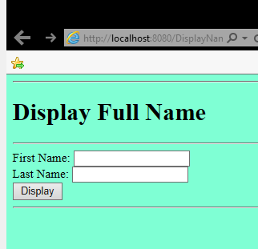

- Add jap page name, disfn.jsp.
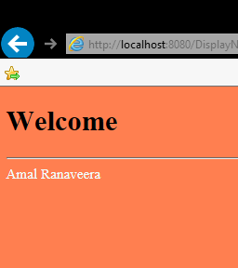
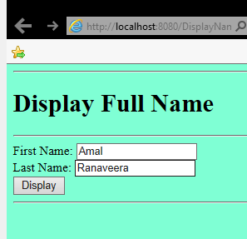
- Write java code to take both parameters and display the full name.

Complete following blanks for above task:
Index.html
<html>
<head>
<title>TODO supply a title</title>
<meta charset="UTF-8">
<meta name="viewport" content="width=device-width, initial-scale=1.0">
</head>
<body bgcolor="Aquamarine">
<hr>
<h1> Display Full Name</h1>
<hr>
<form action="…………….jsp" method="get">

First Name: <input type="……….." name="txtFN">
<br>
Last Name: <input type="…………" name="txtLN">

<br>
<input type="……………" value="Display">

<hr>

</form>
</body>
</html>

disfn.jsp
<%@page contentType="text/html" pageEncoding="UTF-8"%>
<!DOCTYPE html>
<html>
<head>
<meta http-equiv="Content-Type" content="text/html; charset=UTF-8">
<title>JSP Page</title>
</head>
<body bgcolor="Coral">
<h1>Welcome</h1>
<hr>
<font color="Azure">
<%
String fn=…………………..("txtFN");
String ln=request.getParameter("…………..");

String FullName= ……….. + " " + ………….;
out.print(…………………..);
%>

</font>
</body>
</html>

Task 02;
Modify above jsp code as follow:
If any parameter is empty display “Welcome”
Other wise display full name

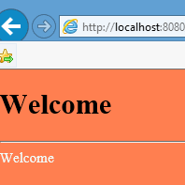
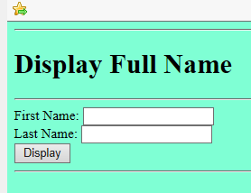

<%
String fn=request.getParameter("txtFN");
String ln=request.getParameter("txtLN");
if (fn.isEmpty() || ln.isEmpty())
{
out.print("Welcome");
}
else
{
String FullName= fn + " " + ln;
out.print(FullName);
}
%>

Task 03:
Crate tile calculator:
Enter width and length of the house and size of the file. Your values are passed in to jsp page and calculate number of tile you need and display them.

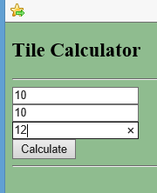
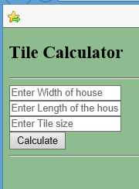
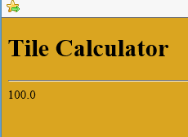

Fill the blanks:
<form action="tcal.jsp" method="post">
<input type="…………….." name="txtw" placeholder="Enter Width of house">
<br>
<input type="……………" name="txtl" placeholder="…………………">
<br>
<input type="text" name="txtts" placeholder="Enter Tile size">
<br>
<input type="submit" value="Calculate">
<hr>

</form>

<%
int w=Integer.parseInt(request.getParameter("……….."));
int l=Integer.parseInt(……………………("txtl"));
int ts=………………………………);
float n= (….*12 * …….*12 )/(….*……);
out.print(n);

%>

All codes:
Task 01 and 02
<!DOCTYPE html>
<!--
To change this license header, choose License Headers in Project Properties.
To change this template file, choose Tools | Templates
and open the template in the editor.
-->
<html>
<head>
<title>TODO supply a title</title>
<meta charset="UTF-8">
<meta name="viewport" content="width=device-width, initial-scale=1.0">
</head>
<body bgcolor="Aquamarine">
<hr>
<h1> Display Full Name</h1>
<hr>
<form action="disfn.jsp" method="get">

First Name: <input type="text" name="txtFN">
<br>
Last Name: <input type="text" name="txtLN">

<br>
<input type="submit" value="Display">

<hr>

</form>
</body>
</html>

%--
Document : disfn
Created on : Feb 27, 2019, 11:38:40 AM
Author : Admin
--%>

<%@page contentType="text/html" pageEncoding="UTF-8"%>
<!DOCTYPE html>
<html>
<head>
<meta http-equiv="Content-Type" content="text/html; charset=UTF-8">
<title>JSP Page</title>
</head>
<body bgcolor="Coral">
<h1>Welcome</h1>
<hr>
<font color="Azure">
<%
String fn=request.getParameter("txtFN");
String ln=request.getParameter("txtLN");
if (fn.isEmpty() || ln.isEmpty())
{
out.print("Welcome");
}
else
{
String FullName= fn + " " + ln;
out.print(FullName);
}
%>

</font>
</body>
</html>

Task 03:
<form action="tcal.jsp" method="post">
<input type="text" name="txtw" placeholder="Enter Width of house">
<br>
<input type="text" name="txtl" placeholder="Enter Length of the house">
<br>
<input type="text" name="txtts" placeholder="Enter Tile size">
<br>
<input type="submit" value="Calculate">
<hr>

</form>

<%
int w=Integer.parseInt(request.getParameter("txtw"));
int l=Integer.parseInt(request.getParameter("txtl"));
int ts=Integer.parseInt(request.getParameter("txtts"));
float n= (w*12 * l*12 )/(ts*ts);
out.print(n);

%>

